Monitoring Task

Task Description:
Install Prometheus and Grafana on a Linux EC2 machine, connect Prometheus to Grafana, and create a dashboard to view metrics.
Techstacks needs to be used :
- AWS EC2
- Prometheus
- Grafana
- Node Exporter
Steps:
Launch EC2 instance by allowing below port in SG
Security Group inbound rules:
SSH – 22
Node Exporter – 9100
Prometheus : 9090
Grafana – 3000

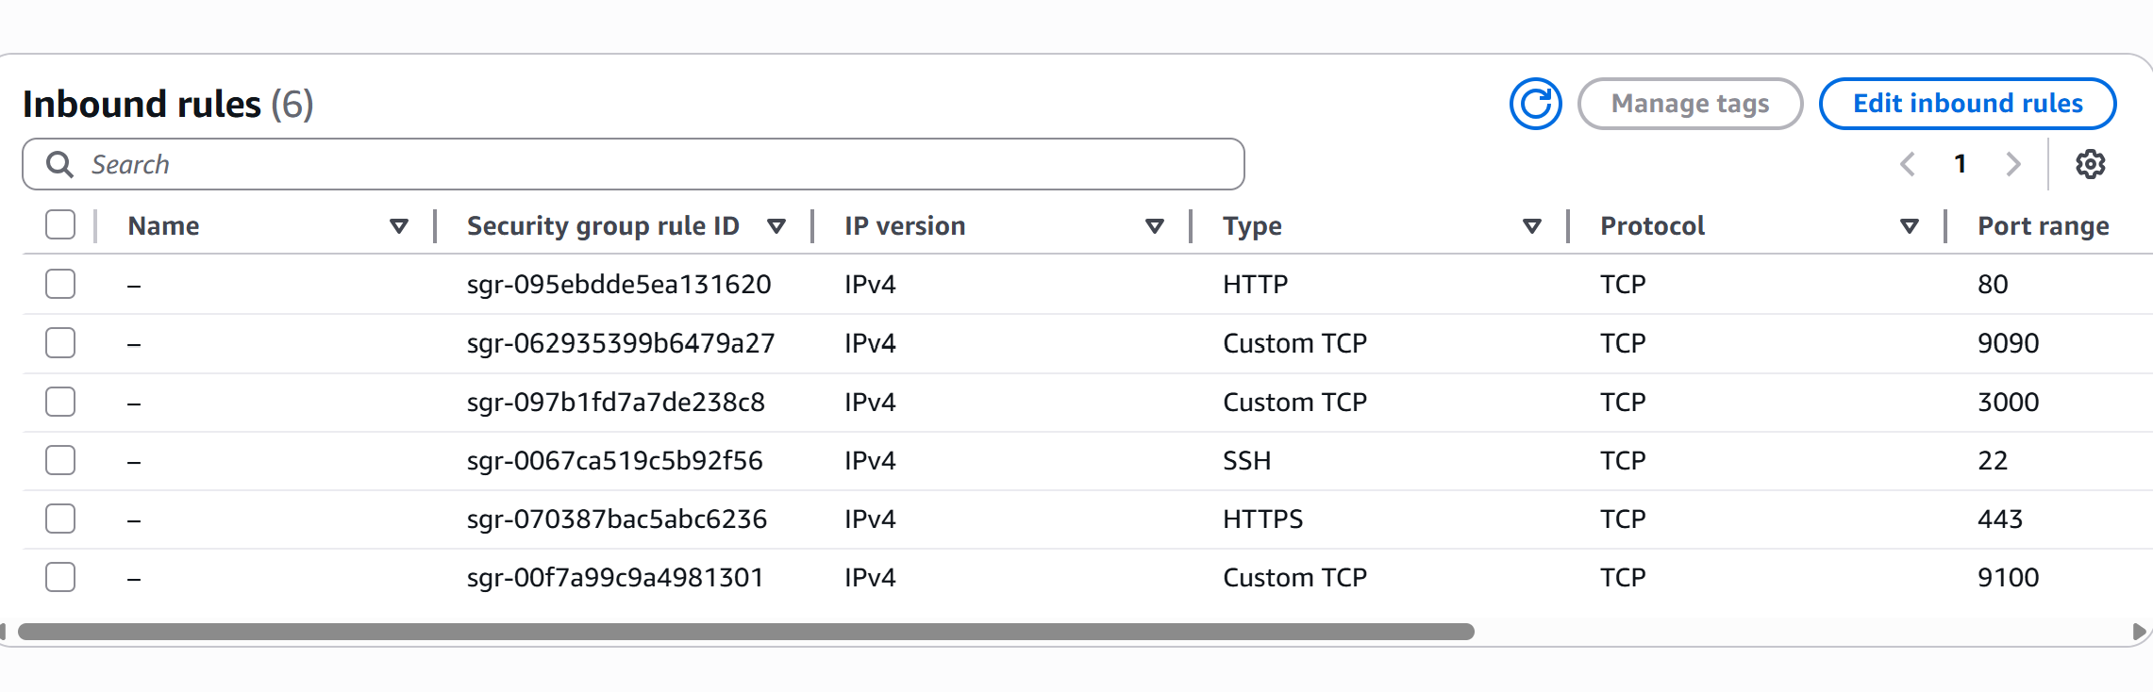

Install Node exporter
# Download

wget https://github.com/prometheus/node_exporter/releases/download/v1.8.1/node_exporter-1.8.1.linux-amd64.tar.gz

# Extract
tar xvf node_exporter-1.8.1.linux-amd64.tar.gz
cd node_exporter-1.8.1.linux-amd64

# Run
./node_exporter &

Node exporter runs on 9100

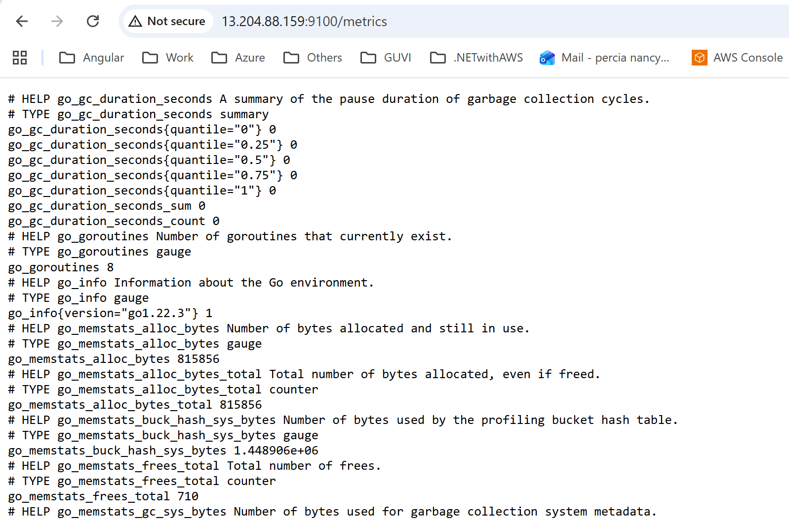

Install Prometheus
# Download
wget https://github.com/prometheus/prometheus/releases/download/v2.55.1/prometheus-2.55.1.linux-amd64.tar.gz

# Extract
tar xvf prometheus-2.55.1.linux-amd64.tar.gz
cd prometheus-2.55.1.linux-amd64

Edit prometheus.yml file using vi or nano editor
Added below highlighted lines under scrape_configs

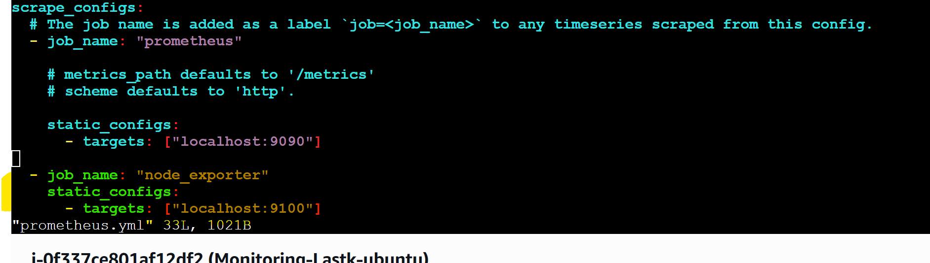

Run Prometheus:
./prometheus --config.file=prometheus.yml &
Prometheus runs on port 9090
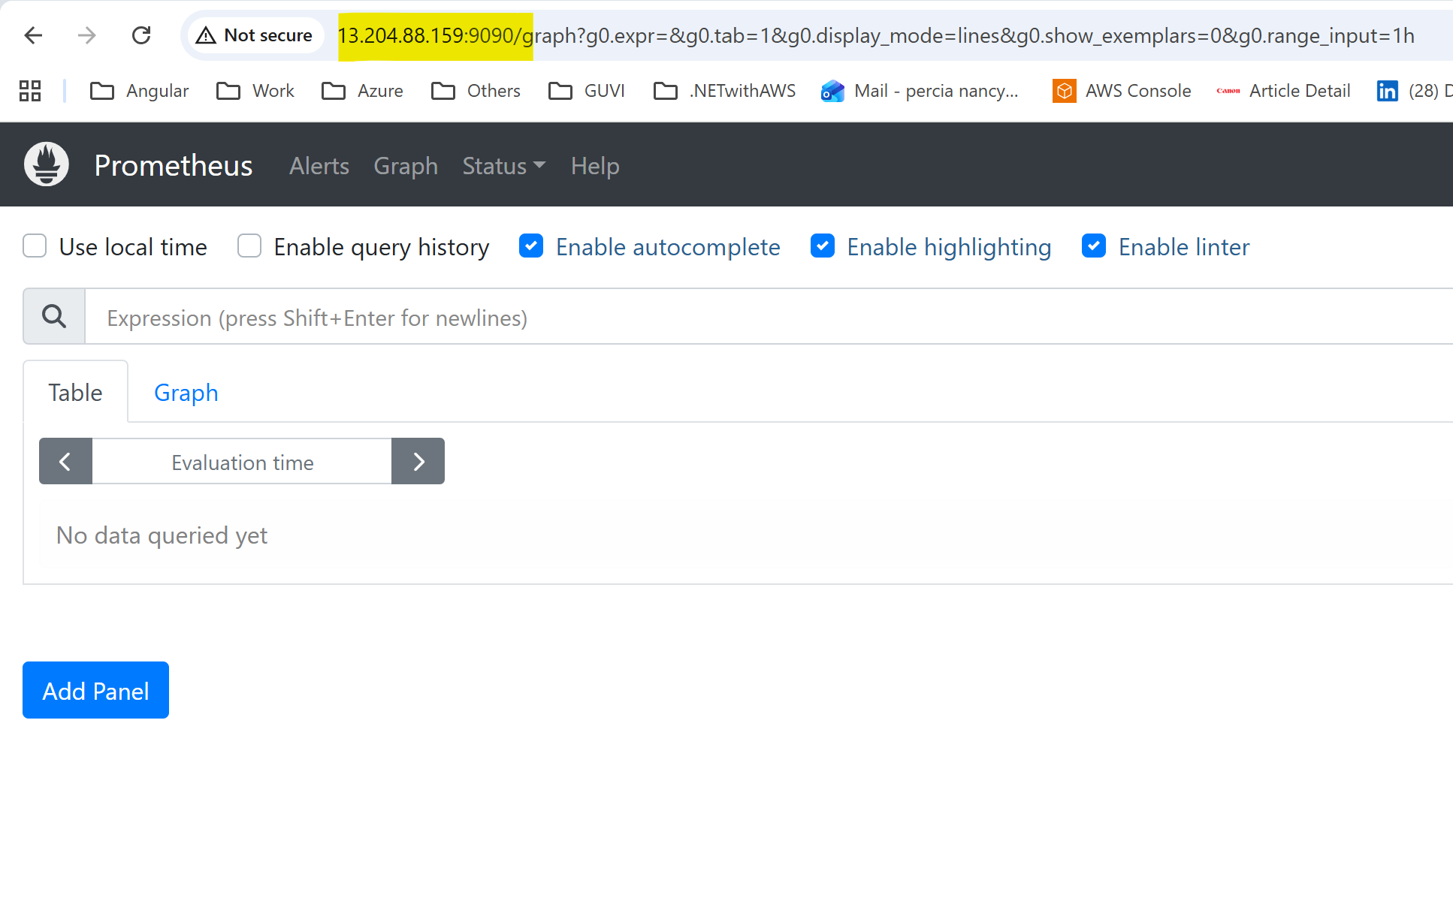
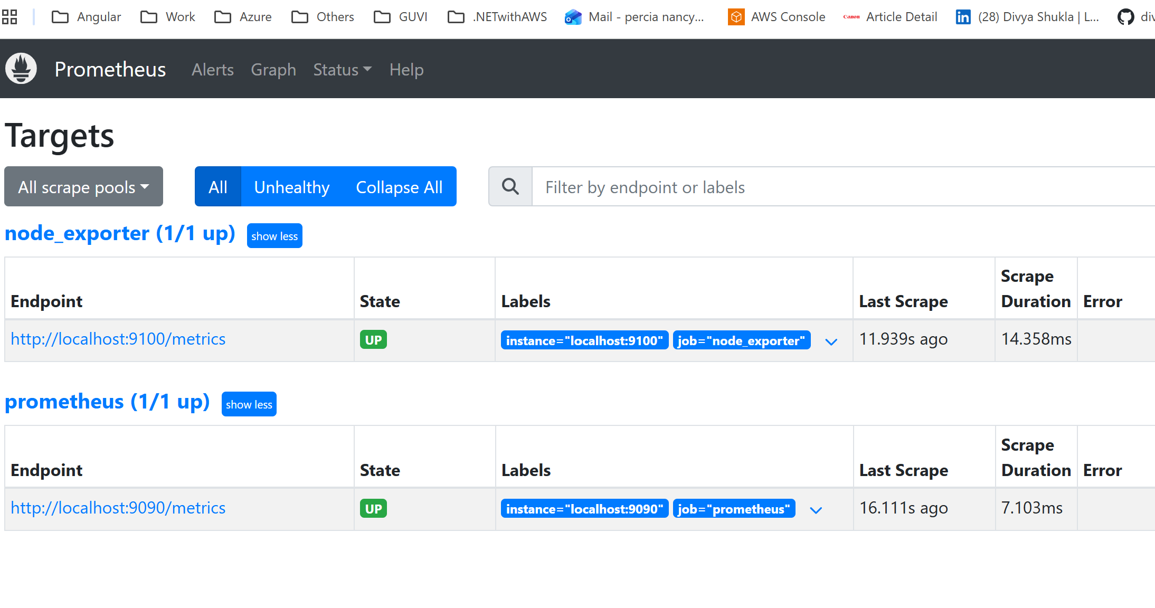

Install Grafana
# Add repo
sudo apt-get install -y apt-transport-https software-properties-common
sudo add-apt-repository "deb https://packages.grafana.com/oss/deb stable main"
wget -q -O - https://packages.grafana.com/gpg.key | sudo apt-key add -
sudo apt-get update

# Install
sudo apt-get install grafana -y

# Start
sudo systemctl start grafana-server
sudo systemctl enable grafana-server

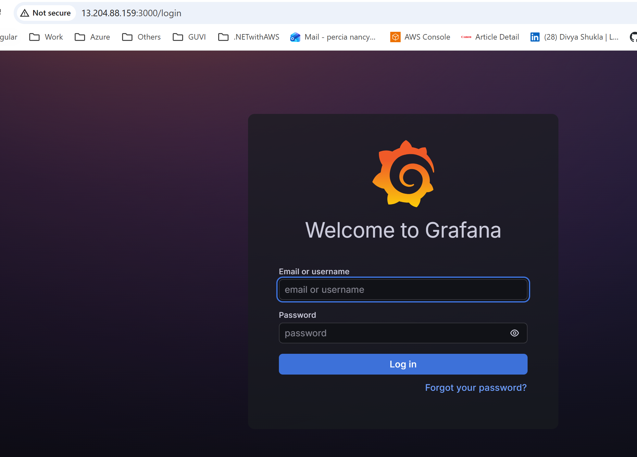

Login: admin / admin

Connect Prometheus to Grafana
- Go to Configuration → Data Sources → Add Data Source
- Choose Prometheus & set the url
- Click Save and Test

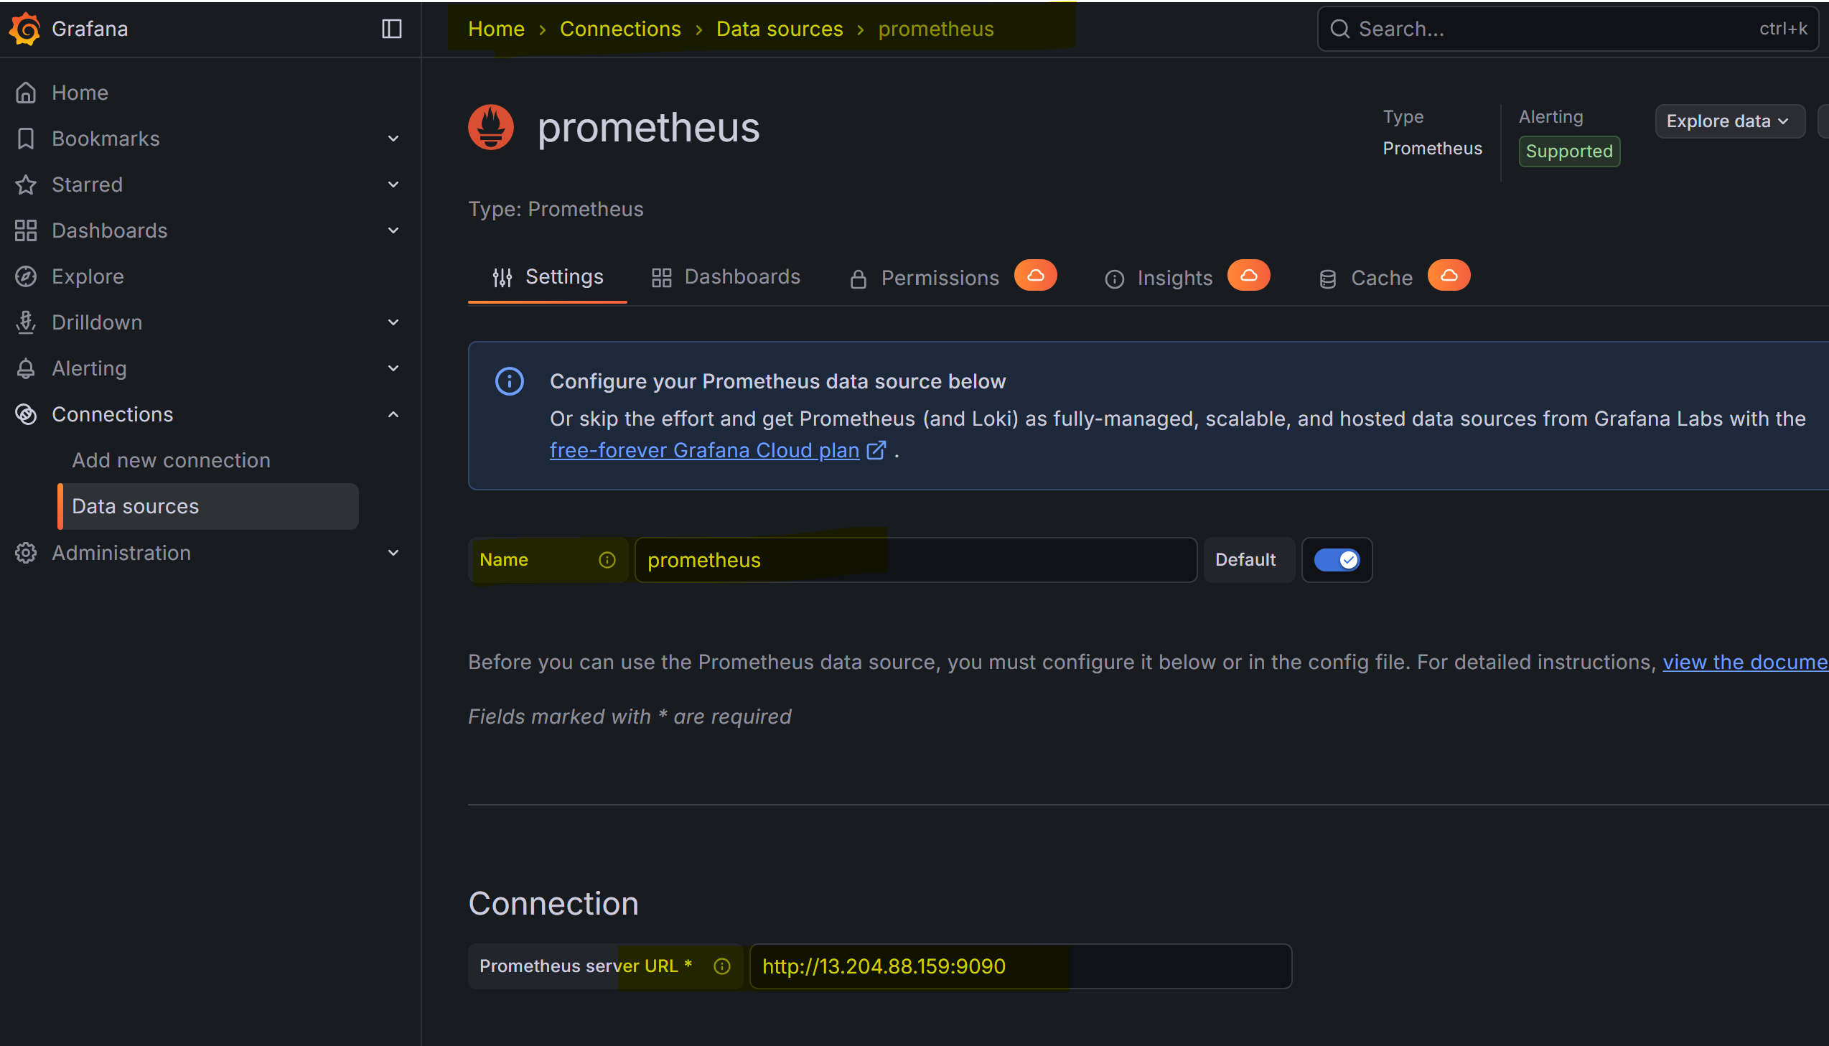

Import Node Exporter Dashboard
- Go to Dashboards → New → Import
- Copy the Node Exporter dashboard full url from Grafana dashboards
- Click Load
4. Select Prometheus as data source
- Click Import

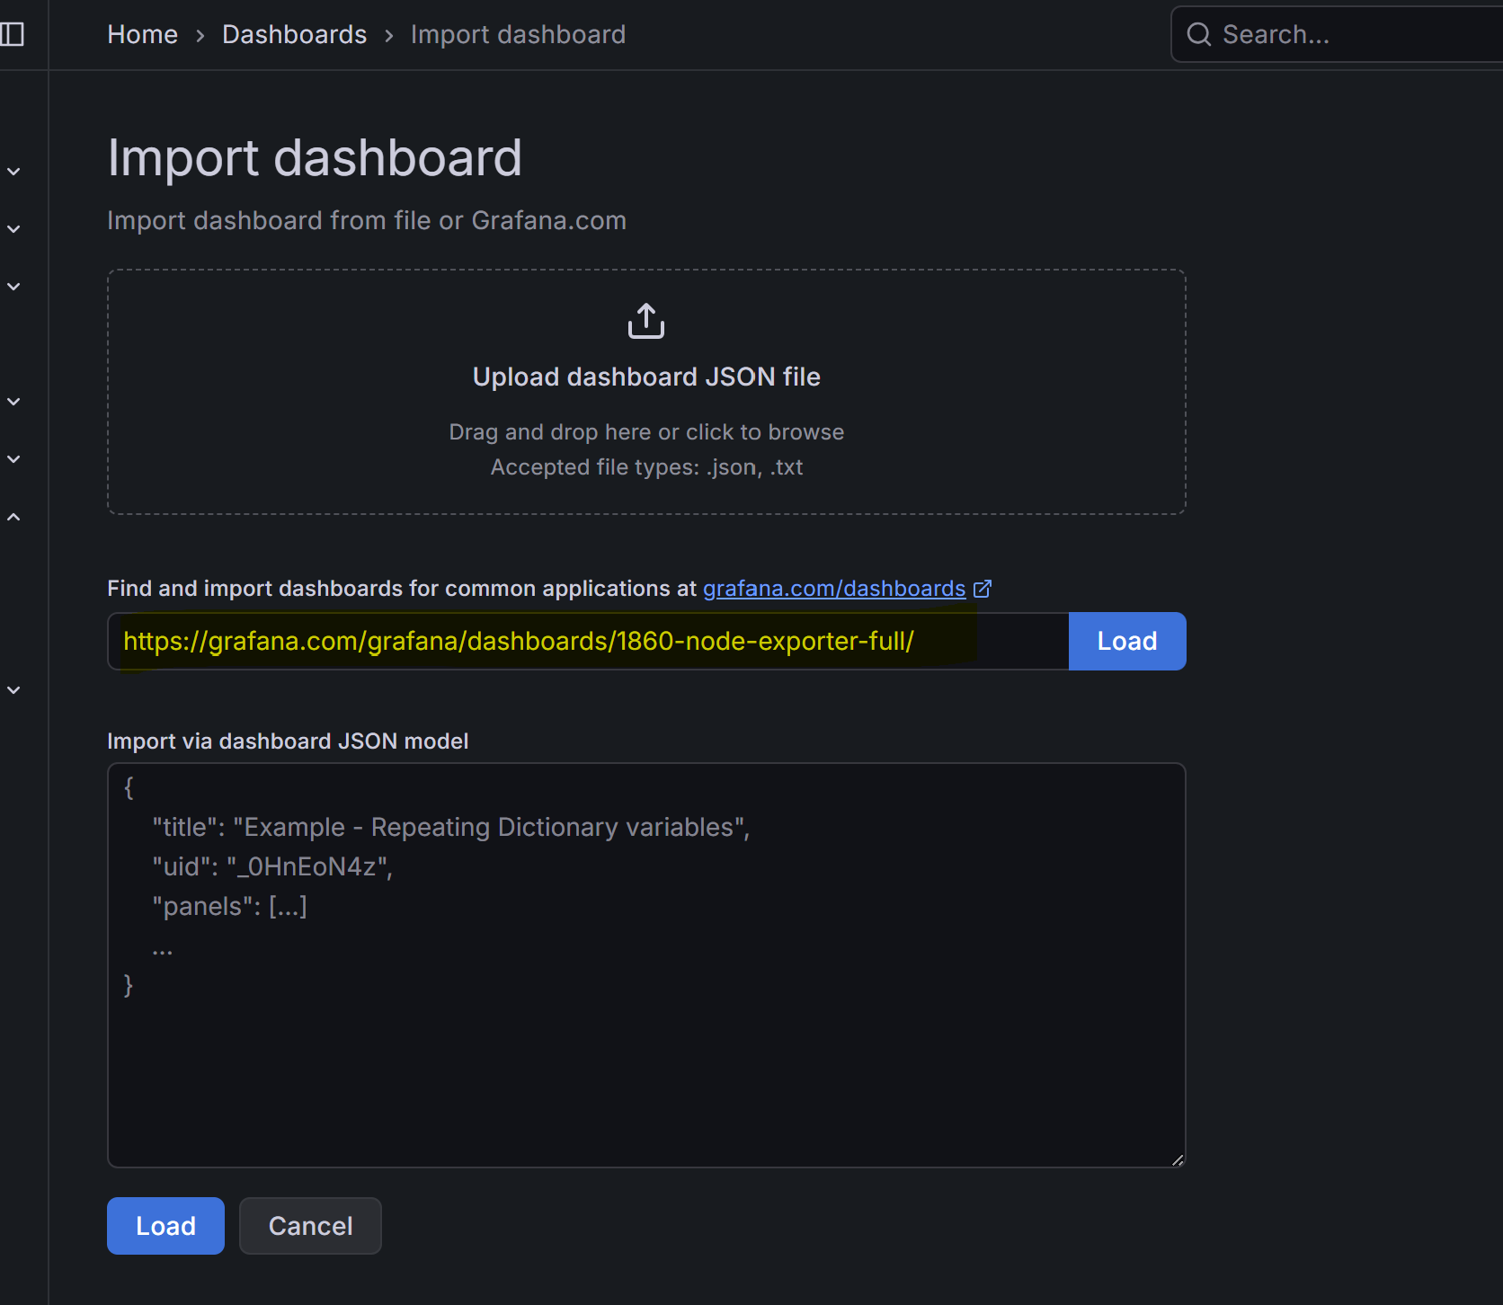

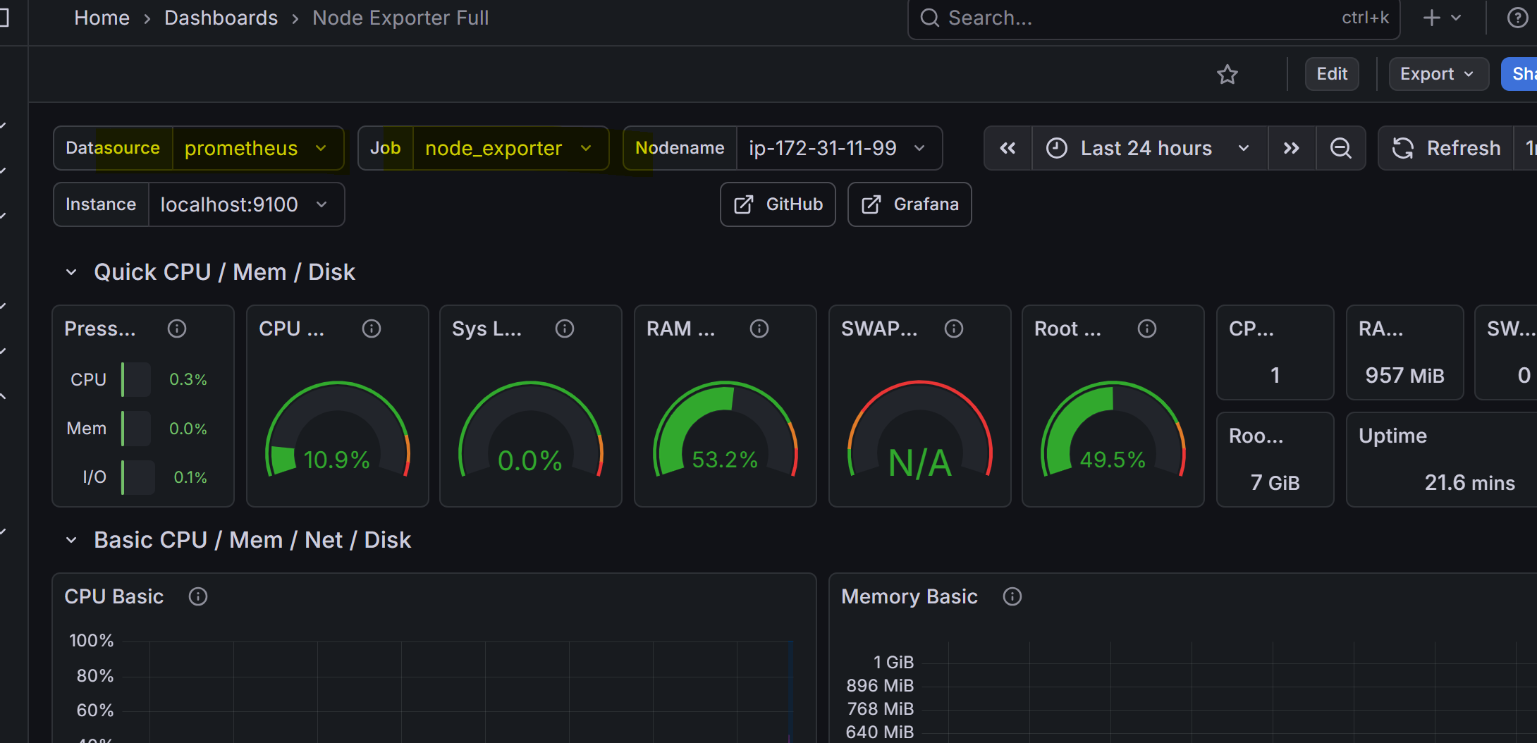
Prometheus scrapes metrics from Node Exporter
Grafana visualizes metrics from Prometheus
Dashboard ID 1860 gives full system view

